Reflection journal template – student volunteer program
This document has been produced by the Department for Education. It is based on resources and artwork created by teachers at Ocean View College. The artist has given permission for use and distribution of the artwork.
The file was produced on 7 June 2018.

Reflection journal

Name:___________________________ Care group: __________

Volunteer organisation:_________________________________

Reflection is so critical; there can be no higher growth for individuals or for society without it. Reflection is the very process of human evolution itself.
-- David Sawyer
I’m going to
volunteer!

What is a journal?
Journals are a written form of reflection in which you will consider your volunteering experience.

Why is reflection important?
Learning comes about not from doing, but from thinking about what you do. Often we go through our day to day life without spending too much time “processing” our experiences. This is not a bad thing, since much of what we do throughout the day is routine and it may not hold a lot of meaningful learning.
When we participate in new experiences, experiences that are outside of our comfort zone or outside of our routine there is often a lot of learning that can take place.
Reflection may include acknowledging or sharing your feelings, reactions, observations and ideas about anything regarding your volunteering activity. Reflection can happen through writing, speaking, listening, reading, creating art, acting and a number of other ways.

Why do I have this journal and what do I do with it?
You will examine your thoughts and experiences through this journal, and further the learning you will do in relation to your volunteering.
Unfortunately, journals are sometimes misused as simple logs of events, thereby missing the reflective component inherent in thinking critically about experiences. So, please don’t just use this journal to record what you did each day. That would be boring and a waste of your time. We want you to go “deeper”…..
As you page through your journal, you will notice that you are required to do some writing and/or drawing every day.
Your journal will start with reviewing the details of the volunteering experience and moves toward critical thinking, problem solving, and creating an action plan. We are confident that your week volunteering will make you want to take action! Actions that will be benefit you and the community which you’re a crucial part of.

How do I go from experiencing to taking action?
Well, without even knowing it, you will actually go through a cycle called the experiential learning cycle:
  - Experiencing
(You participate in the volunteering activity)
  - Reflecting
(You reflect on your volunteering)
  - Generalising
(You come up with some insight and
meaning from the volunteering experience)
  - Applying
(You incorporate that insight into your life)
What?
So what?
Now what?

Graduate qualities and capabilities
Research shows that volunteering makes a difference in the lives of all those involved and the community as a whole. The positive impact of youth involvement in particular is undeniable.
As you have heard from many guest speakers, university personnel, teachers and friends, volunteering improves employment opportunities and delivers skilled employees as well as helping the local and wider community.
Over the next week you will have opportunities to intentionally and unintentionally develop your graduate qualities and capabilities. Complete the pre-volunteering self-appraisal on the following page. The idea is that you roughly gauge your current level of each quality and capability. You will then repeat this exercise at the end of your week.

Pre-volunteering self-appraisal
Choose a number on the 0-5 scale to indicate what you think your current level of each quality/capability is
Quality or capability | Your self-appraisal
Communication  Communicate to suit particular purposes, contexts and cultures  - Speak clearly and directly  - Write to convey meaning  - Listen for understanding  - Read for understanding  - Use numeracy to communicate  - Understand, interpret and act  - Recognise and respond to diverse perspectives | 0 1 2 3 4 5  Not satisfactory Satisfactory Excellent
Teamwork  Develop working relationships that are based on independence  - Work in a team  - Identify strengths - own and those of other team members  - Fulfil personal obligations to the team  - Work with a diverse range of people  - Cooperate and collaborate  - Develop strategies to manage conflict  - Support the team objectives | 0 1 2 3 4 5  Not satisfactory Satisfactory Excellent
Initiative and enterprise  Take up opportunities and adapt to changing situations  - Recognise new opportunities and generate new ideas  - Develop a range of creative and practical opinions  - Translate strategies into action and evaluate their worth  - Work with others to implement strategies and solve problems  - Use logical and critical thinking to solve problems and reflect  - Work independently and show initiative | 0 1 2 3 4 5  Not satisfactory Satisfactory Excellent
Work in a digital world  Use digitally based technologies and systems  - Connect with others  - Generate ideas and solutions  - Use ICT and technology responsibly and ethically and manage risk  - Access, organise and present information | 0 1 2 3 4 5  Not satisfactory Satisfactory Excellent
Planning and organising  Develop, implement and articulate plans to achieve visions  - Develop a vision and a practical plan to implement it  - Make decisions  - Plan and organise workload and commitments  - Plan and use of time and other resources, including people  - Reflect on and evaluate progress | 0 1 2 3 4 5  Not satisfactory Satisfactory Excellent
Self-management  Review and plan the development of own skills  - Develop self-awareness and set directions  - Employ a range of learning strategies to develop relevant skills and  - knowledge  - Participate in learning, work and community life  - Work with roles and responsibilities  - Recognise and respond to protocols in workplace/community | 0 1 2 3 4 5  Not satisfactory Satisfactory Excellent

If you’re in the mood….. some mindfulness colouring

What’s my mindset?
We are all born with a set of skills & abilities BUT it’s not what you are born with that matters; it’s your mindset that matters.

⇑ Highlight the phrases you often feel

Fixed Mindset: I believe my talents and abilities are set in stone. I must prove yourself over and over, trying to look smart and talented at all costs.
Growth Mindset: I know that talents can be developed and that great abilities are built over time. I believe that my qualities can be cultivated through my efforts.
I believe I currently have a _________mindset

Mindset activity
- Using the worksheet below, list two things you have a Growth Mindset about and up to 2 things you have a Fixed Mindset about.
- What are some of the “in the moment” thoughts you have when faced with doing the things you have listed?
- Are there any past experiences that have amplified or confirmed this mindset for you?

Growth mindset
Activity | “in the moment” thoughts | Past experience
Example: Making friends | Example: I like making new friends | Example: I’ve made many new friends
1.

2.

Fixed mindset
Activity | “in the moment” thoughts | Past experience
Example: Riding a bike | Example: I don’t have the balance | Example: I fell off once & didn’t try again
1.

2.

I’m going to develop my growth mindset
For this activity, think about your strengths.
Ask people who know you, what you do well and where you need to grow.
Fixed mindset activity/experience:

“In the moment” thoughts | What can my Growth Mindset voice say back?
Example: I’m not good at maths | Example: If I practice it, I can be good at maths
What obstacles might you face? | How can the obstacles be overcome?
Example: It doesn’t come easily | Example: Persist!
What could you do to increase you efforts or skills to become better at this?

Who will you seek feedback from:

What is going to be your motivation to effect this change?
It’s a good idea to have both intrinsic (from within you) and extrinsic (outside) motivation

Before I volunteer

Why?
Why did you choose to volunteer your time with the organisation that you have?

Get digging
As you would if you were going for a job interview, it is crucial that you do some research about the organisation that you are going to volunteer for.

Organisation’s website address:
www._________________________________________________________________

Mission statement, goals or aim:

Community or clients:

Locations:

My expectations
To get you to start thinking about your expectations for the volunteering experience, briefly complete the sentences below:
"During this week, I hope...”

"I am most anxious about..."

Draw an image
Draw an image about the people or objects you will be working with next week. Think about the subject matter or your feelings about the volunteering program. Everyone can draw!

Grounding exercise
Name 3 things you:
- see
- smell
- hear
- feel
Breathe in and out slowly 3 times.

This is called grounding.
It can help when you feel like you have lost all control of your surroundings.
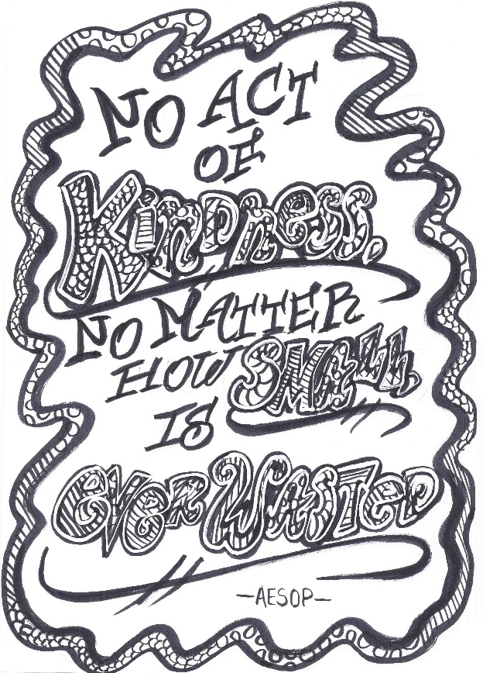

If you’re in the mood….. some mindfulness colouring

Monday

Setting the scene
What does a typical day volunteering at your organisation look like?

What was the flow of feelings during the day? Think about the highs, the lows, the quiet times.

Daily gratitude visit

List anything that happened today you’re grateful about.

Why do you feel grateful?

I’m grateful

If you’re in the mood….. some mindfulness colouring
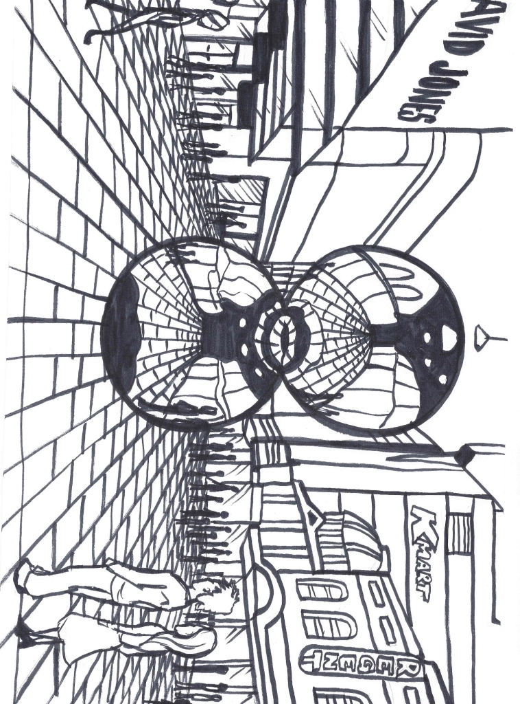

Tuesday

Poetry or writing slam
Write a short poem or creative sentences about your day today.

Self-pride
What is one thing you did today that made you proud?

“Hunt for the good stuff” journal
Think of 3 good things that have happened in the last few days.

The good stuff | About the good stuff
Good stuff 1: | Why did this good thing happen?
 | What does this good thing mean to me?
 | How can I get more of this good thing into my life?
Good stuff 2: | Why did this good thing happen?
 | What does this good thing mean to me?
 | How can I get more of this good thing into my life?
Good stuff 3: | Why did this good thing happen?
 | What does this good thing mean to me?
 | How can I get more of this good thing into my life?

If you’re in the mood….. some mindfulness colouring

Wednesday

Volunteering alongside peers
You have volunteered with your friends and peers for a few days now.
What have you learnt about working with these people?
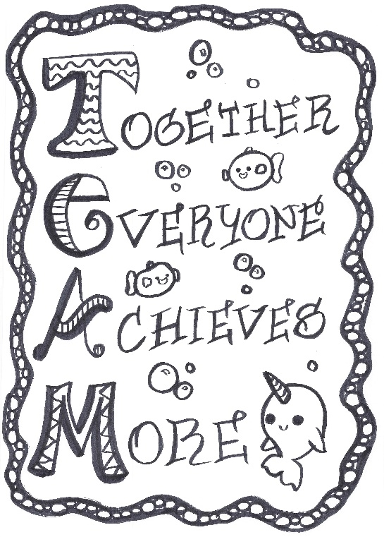

Best thing
What is the best thing that happened to you this week so far?

Changes?
If you were in charge, what would you change about the organisation?

Daily gratitude visit
List anything that happened today that you’re grateful about.

Why do you feel grateful?

You’re half way through your volunteering week…..

Please circle how you feel:
- Happy
- Relieved
- Really happy!
- Disappointed
- So happy I’m crying
- Sleepy
- Bored
- Crying
- I don’t have strong feelings
- Not so great
- Worried
- Confused?
- Angry
- Really angry.
- Tired
- Exasperated
- Disappointed, but relieved
- Afraid
- Horrified
- Astonished
- Embarrassed

Please explain why you circled the feelings you did:

Thursday

The free write
Set the timer on your phone for 2 minutes. When you press start, write continuously by keeping your pen moving ... even if only to write: “I don’t know what to write.”
Start your writing with, “During this volunteering program, I don’t think I’ll ever forget…”

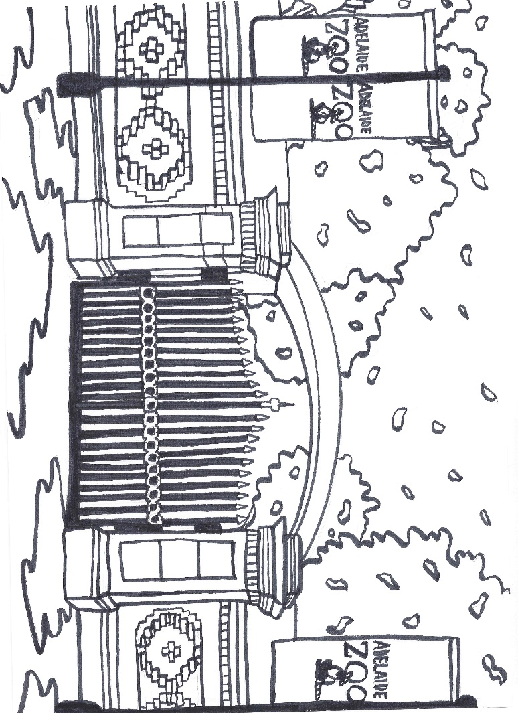

…. keep writing….

Write a letter
Write a letter to someone in your family or your favourite teacher about the most important things you will take with you from the volunteering experience. Think about what it has meant to you.
Sharing your
volunteering
experience

…. your letter continued….

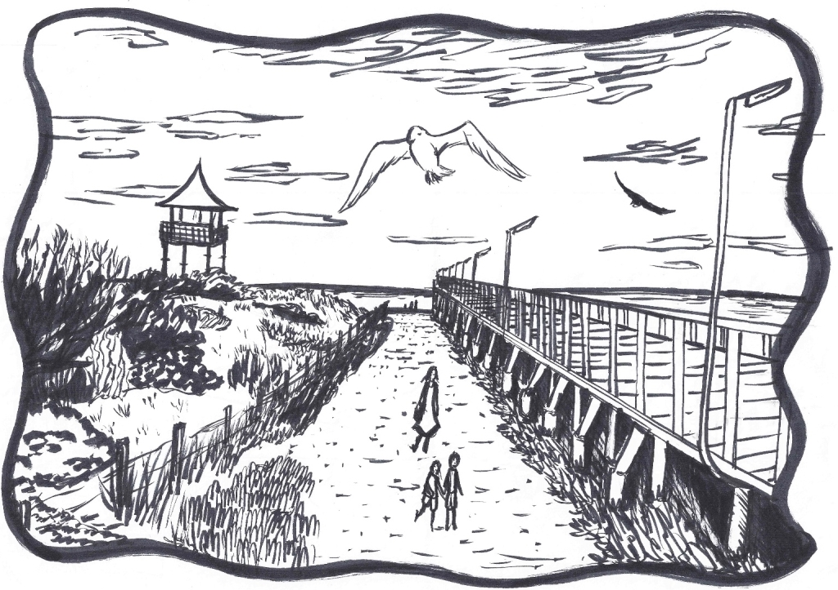

Revisit your Image
Go back and look at the image you drew before you started your volunteering week.
Redraw, not copy, the image.

Has it changed? If so, why do you think it changed?

Daily gratitude visit
List anything that happened today for which you feel grateful.

Why do you feel grateful?

A thought:
Would it be appropriate to express your gratitude?
Maybe express it – a verbal thank you, a letter, or just do something kind.

Friday

Being the change

Describe one change you would like to see in the world?
(for example, homelessness)

How would this change benefit you? Others? The world?

What would it cost you?

How has this volunteering experience prepared you to work for this change?

What skills have you developed that will help you be a change agent? What skills do you want to develop?

What could you be doing right now to work for this change?

Pros and cons

What were the best and worst parts of this volunteering program?

“Hunt for the good stuff” journal
Think of 1 good thing that has happened lately.

The good stuff | About the good stuff
Good stuff 1: | Why did this good thing happen?
 | What does this good thing mean to me?
 | How can I get more of this good thing into my life?

Looking forward

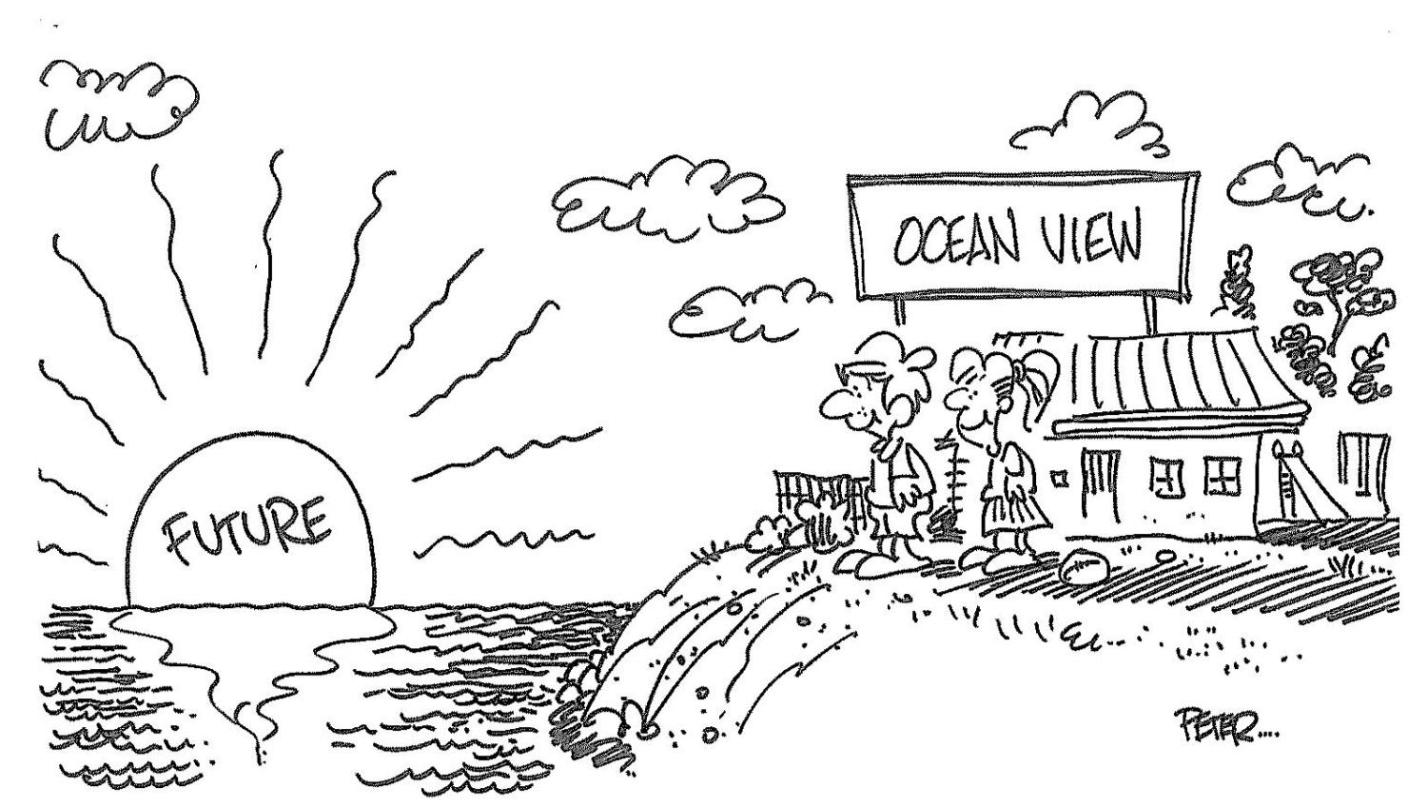

What is something in your life that brings you courage, that gives you hope?

What do you think it means to be a global citizen?

How do you think you might continue to volunteer after this experience ends?

How can you continue to feel like you are giving back to the community?

Post-volunteering self-appraisal
Choose a number on the 0-5 scale to indicate what you think your current level of each quality/capability is now:
Quality or capability | Your self-appraisal
Communication  Communicate to suit particular purposes, contexts and cultures  - Speak clearly and directly  - Write to convey meaning  - Listen for understanding  - Read for understanding  - Use numeracy to communicate  - Understand, interpret and act  - Recognise and respond to diverse perspectives | 0 1 2 3 4 5  Not satisfactory Satisfactory Excellent
Teamwork  Develop working relationships that are based on independence  - Work in a team  - Identify strengths - own and those of other team members  - Fulfil personal obligations to the team  - Work with a diverse range of people  - Cooperate and collaborate  - Develop strategies to manage conflict  - Support the team objectives | 0 1 2 3 4 5  Not satisfactory Satisfactory Excellent
Initiative and enterprise  Take up opportunities and adapt to changing situations  - Recognise new opportunities and generate new ideas  - Develop a range of creative and practical opinions  - Translate strategies into action and evaluate their worth  - Work with others to implement strategies and solve problems  - Use logical and critical thinking to solve problems and reflect  - Work independently and show initiative | 0 1 2 3 4 5  Not satisfactory Satisfactory Excellent
Work in a digital world  Use digitally based technologies and systems  - Connect with others  - Generate ideas and solutions  - Use ICT and technology responsibly and ethically and manage risk  - Access, organise and present information | 0 1 2 3 4 5  Not satisfactory Satisfactory Excellent
Planning and organising  Develop, implement and articulate plans to achieve visions  - Develop a vision and a practical plan to implement it  - Make decisions  - Plan and organise workload and commitments  - Plan and use of time and other resources, including people  - Reflect on and evaluate progress | 0 1 2 3 4 5  Not satisfactory Satisfactory Excellent
Self-management  Review and plan the development of own skills  - Develop self-awareness and set directions  - Employ a range of learning strategies to develop relevant skills and  - knowledge  - Participate in learning, work and community life  - Work with roles and responsibilities  - Recognise and respond to protocols in workplace/community | 0 1 2 3 4 5  Not satisfactory Satisfactory Excellent

My notes

